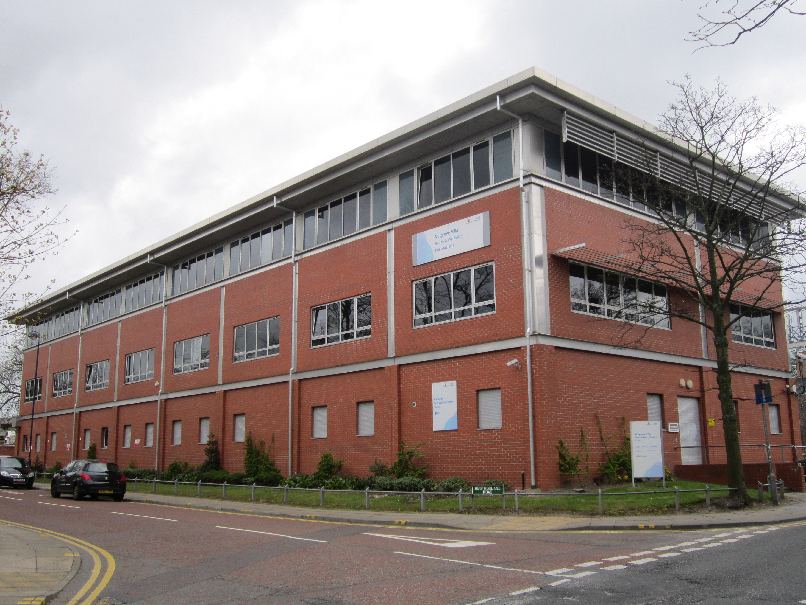

**Welcome**

**To Nutrgove Villa Surgery**

Dr Rajendran Kulandaisamy and Dr S R Maddipati welcome you to Nutgrove Villa Surgery set in the heart of the community in Huyton. We provide care for the residents of the L36 postcode.

Thank you for choosing Nutgrove Villa Surgery for your ongoing NHS primary care. Welcome to our practice.

**Dr Rajendran Kulandaisamy**   
(Male) MBBS FRCD MRCGP DFSRH

**Dr S R Maddipati**  
(Male) MBBS MRCP (UK) MRCP (EDIN) MRCGP  
  
**Miss Lyndsey Reid**  
Practice Manager

**Nutgrove Villa Surgery**

Nutgrove Villa  
Westmorland Road  
Huyton  
L36 6GA

**Appointments**

0151 489 2276

**General Enquiries**

0151 489 3403  
0151 511 5909  
  
**Email**   
(for repeat medication requests only)  
[nutgrove.reception@knowsley.nhs.uk](mailto:nutgrove.reception@knowsley.nhs.uk)

**DISABLED ACCESS**

The practice premises has suitable access for disabled persons.



**Practice Leaflet**

**Nutgrove Villa Surgery**

**www.nutgrovevillasurgery.nhs.uk**

# **OPENING TIMES & APPOINTMENTS** Surgery Opening Times

Mon 8:00 - 18:30  
Tue 8:00 - 19:30  
Wed 8:00 - 18:30  
Thu 8:00 - 18:30  
Fri 8:00 - 18:30  
Sat Closed   
**Sun Closed**

**Appointments**  
  
Consultations with a GP or nurse are by appointment only. Appointments can be made by telephoning the surgery or by a personal visit. If you have a preference of GP please inform the receptionist when making an appointment.

**Mon 9:30-11:50 / 15:20-17:30  
Tue 9:30-11:50 / 14:20-17:30  
Wed 9:30-11:50 / 14:20-17:30  
Thu 9:30-11:50 / 14:20-17:30  
Fri 9:30-11:50 / 15:20-17:30  
Sat Closed  
Sun Closed**

**We are not a limited company.**

**We are not a teaching/training medical practice.**

**HOME VISITS**

If you are known to us as a housebound patient and a home visit is needed please telephone the surgery before 11am. You may be contacted by one of the doctors for further information. Every effort should be made to attend surgery if you are not a housebound patient. Remember, in the time it takes to visit you at home, the doctor can see several patients in the surgery.

**CLINICS AND SERVICES**

* Child Health Surveillance Services
* Contraceptive Services
* Carers Health Checks
* Cervical Screening
* Maternity Medical Services
* Minor Surgery Services
* Health Screening
* Holiday Vaccinations
* Immunisations
* Chronic Disease Lead Clinics:  
  - Asthma  
  - Diabetes   
  - Chronic Heart Disease  
  - Chronic Obstructive Pulmonary Disease

**PATIENTS WISHING TO SPEAK TO THE DOCTOR OR NURSE**

Telephone calls will not be put through to the doctors or nurse during clinic times.

A message will be taken and someone will call you at the end of the clinic or you may be asked to call the surgery back at the end of clinic.

.  
 **NEW PATIENTS**  
  
New patients wishing to be registered must live within the practice area (L36) . Application forms are available from reception and an appointment with the practice nurse for a new patient medical is also required before registration is completed.



# **COMMENTS AND SUGGESTIONS**

We endeavor to provide a high standard for our patients. If you have any complaints, comments or concerns or want to suggest any improvements, please contact the practice manager in writing. We operate a practice complaint procedure as part of the NHS system for resolving complaints.

**FEEDBACK**

Why not share your comments on NHS Choices or Health watch Knowsley Feedback Centre? It only takes minutes to register your comments

<https://www.nhs.uk/Services/GP/Overview/DefaultView.aspx?id=37629>

<https://www.healthwatchknowsley.co.uk/services/nutgrove-villa-surgery-liverpool-l36-6ga/>

**ZERO TOLERANCE**

Any form of violent, aggressive or abusive behavior shown towards any of our staff is unacceptable and will not be tolerated. Individuals behaving violently towards staff will be reported to the police.

# **CONFIDENTIALITY**

Why we collect information about you

The Doctors and staff along with others who care for you keep records about your health and any care or treatment you receive from the NHS. It is important to keep records to help ensure that you receive the best possible care from us. Your record will contain basic details about you.

How we keep your records confidential

Your records are kept in a safe place in the surgery - usually on NHS approved secure software. Receptionists and secretarial staff are responsible for keeping your records in order and from time to time will access your records.

Other agencies

On the odd occasion you may be receiving care from other people such as social services, we may need to share some information about you so that we can work together for your benefit. We will pass on information about you if they have a genuine need for it. There may also be other agencies that may ask for information but we cannot give details without your permission, unless we have concerns regarding safety of children or a vulnerable adult.

**We will not without good reason** give your medical details over the phone unless we are certain of who we are talking to. We will not give details about you to anyone else without your permission.



NHS Cheshire and Merseyside

Nutgrove Villa, Westmorland Road, L36 6GA.

0151 244 4126

Knowsley.ccgcommunications@knowsley.nhs.uk

**Carers**

This practice recognises unpaid carers and the role they play supporting people living in the community. Here at Nutgrove Villa we try to identify our patients who have a caring role so that we can offer support and do our best to accommodate your appointments alongside your caring role. Please let a member of the practice team know if you have a caring role.

**ALLOCATED GP**

Patients will be informed of their named GP at the first appropriate interaction with the practice. You will be assigned to your named GP based on the first initial of your surname.

Surnames A-J allocated to **Dr Raj Kulandaisamy.**  
  
Surnames K-Z allocated to **Dr Maddipati.**

**PRACTICE STAFF**

Along with the doctors who look after patient care, our team compromises of the following staff Lorraine Coogan Practice Nurse RGN - responsible for health clinics and patient care

**Midwife** - antenatal/postnatal care shared with Whiston and Liverpool Women’s Hospital

**HEALTH CHECKS**

Health checks are available to patients between the age of 16 and 75 who have not seen the doctor in the last 3 years. Patients over 75 years old are entitled to an annual health check.

# **REPEAT PRESCRIPTIONS**

We accept email requests

Patients on regular medication do not always need to see a doctor for repeat of medicines. Repeat prescriptions can be ordered in writing or by completing the tear off slip on the right hand side of the prescription by ticking the medication you require. They must be placed in the box by reception or by post.

Please give 48 hours notice for prescription requests. Telephone requests will not be accepted.

Please email your repeat medication requests to:

[**nutgrove.reception@knowsleyccg.nhs.uk**](mailto:nutgrove.reception@knowsleyccg.nhs.uk)

**OUT OF HOURS**

When we are closed

When we are closed and it is not a medical emergency but you need medical help fast, please call NHS 111. Calls are free including mobiles and the line is available 24 hours a day.

You should use NHS 111 if:

* You need medical help fast, but it is not a 999 emergency
* You think you need to go to A&E or Emergency Department or another NHS Urgent Care service
* You don’t know who to call for medical help
* You require health information or reassurance of what to do next

| **www.NutgroveVillaSurgery.nhs.uk** | | |
| --- | --- | --- |
| 0151 489 2276 | 0151 489 3403 | 0151 511 5909 |
| **nutgrove.reception@knowsley.nhs.uk** | | |

# **HAVE YOUR SAY**

PATIENT PARTICIPATION GROUP (PPG)

Our practice has a small number of patients that form our Patient Participation Group (PPG).

Our PPG meet and discuss different services and challenges within the health service with Dr Maddipati and our practice team.

It is a chance to have you say and help shape service improvements while also learning about developments within the NHS.

We are actively recruiting new members, particularly patients who can bring the younger patient view to the group

To join ask any of the practice team.

COMPLIMENTS, COMMENTS AND COMPLAINTS

If you would like to provide feedback to our practice, please do so at your earliest convenience by contacting the practice manager, Lyndsey Reid.

Lyndsey will endeavor to provide you with a swift resolution to your comment or complaint.

If you would like to put your complaint in writing please address it to Lyndsey Reid at the surgery address. We will contact you to let you know we have receipt of your complaint, carry out a thorough internal investigation and respond to you with the appropriate outcome.

**USEFUL TELEPHONE NUMBERS**

**Whiston Hospital**  
0151 426 1600  
  
**St Helens Hospital**  
01744 26633  
  
**Alder Hey Hospital**  
0151 338 4811  
  
**Royal Liverpool Hospital**  
0151 706 2000  
  
**Broadgreen Hospital**  
0151 282 6000  
  
**University Hospital Aintree**  
0151 525 5980  
  
**The Walton Centre**  
0151 525 3611  
  
**Women’s Hospital**  
0151 708 9988